# Check density, most frequent items & itemset/transaction distribution

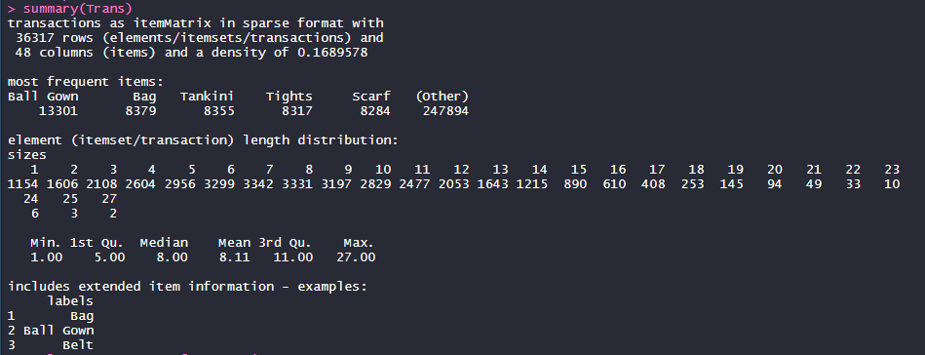

# plot top 50 most frequent items

> itemFrequencyPlot(Trans, topN = 50)

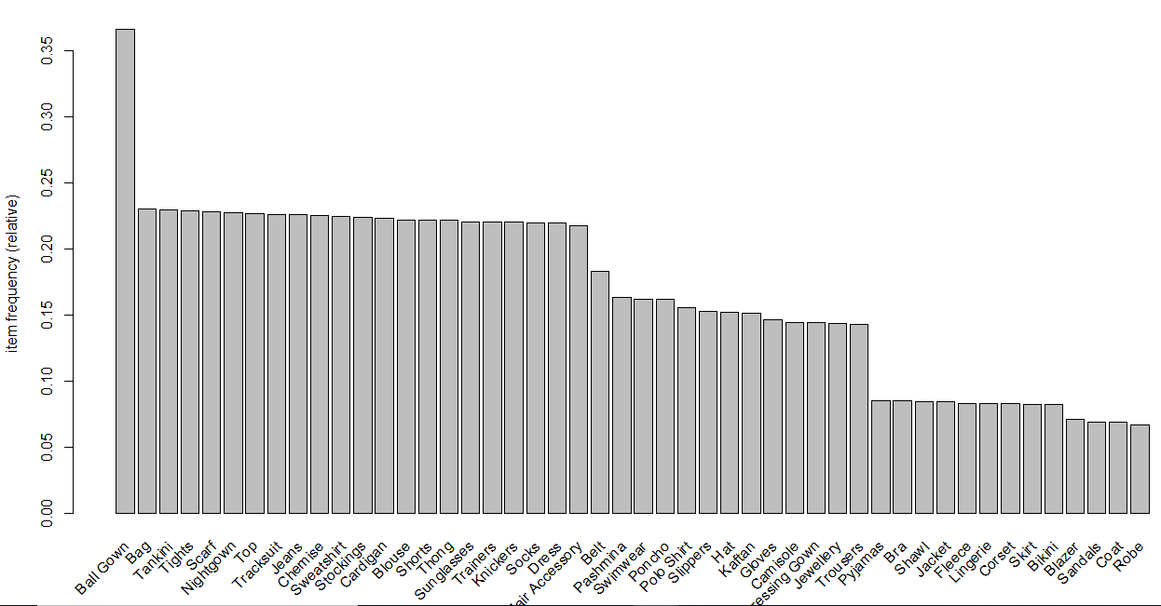

# Most frequent items matches with shown in summary

# Create rules using apriori algorithm

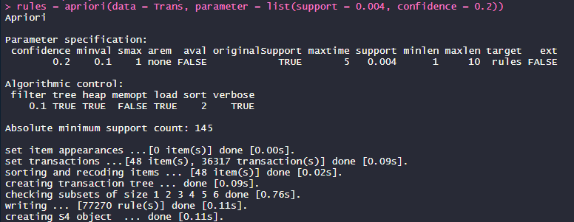

# show rules with top 10 lift values

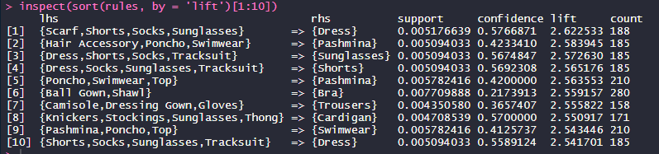

Rules shows most frequent items bought together. Now marketing team could use this associated items (in same basket) make strategy to display items in store.